Comfort Food for Cold Weather
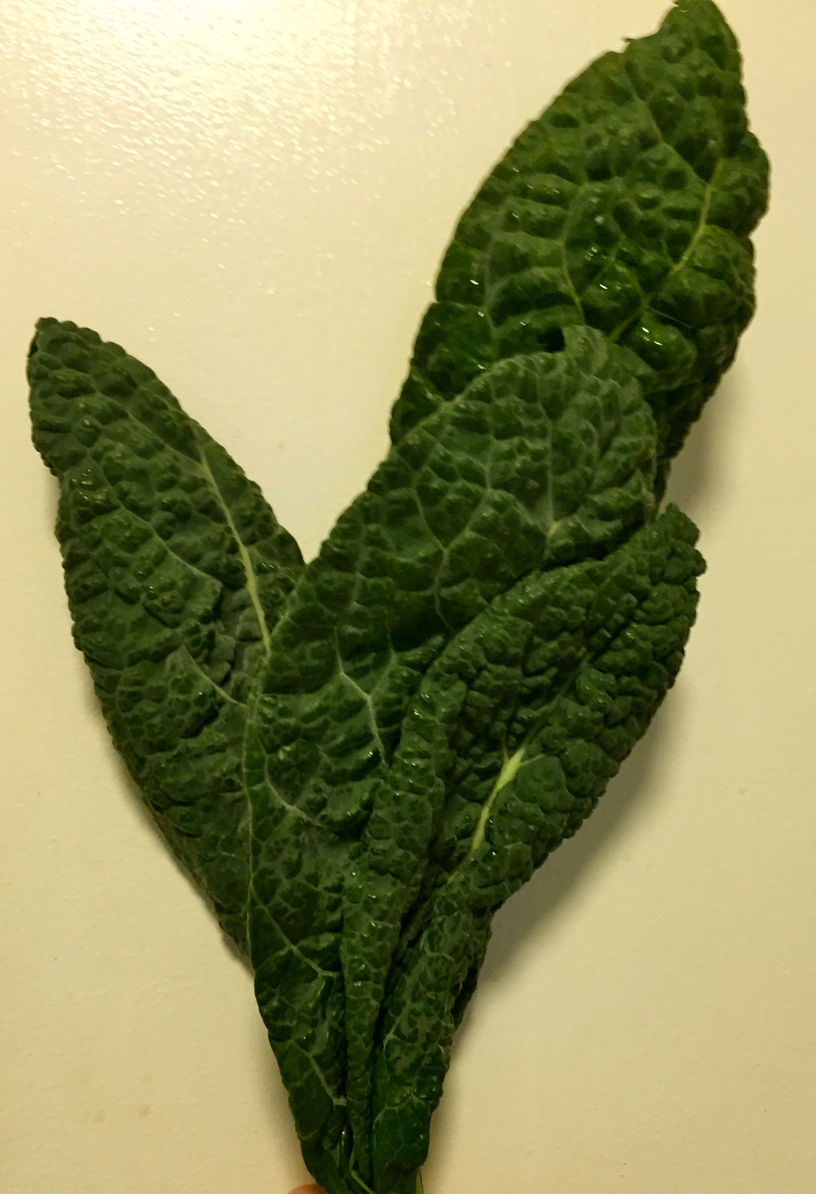
My favorite foods are those that are nourishing for both the body and soul. When the days get cold and dark, soup becomes a significant part of my diet. I like to create soups that are yummy and comforting, as well as good for building immunity and packed with nutrition. To this end Kale and Leek Soup is one of my go to recipes during the cold, wet days of winter. This simple soup is a staple in my kitchen, and my freezer. Easy to prepare, and packed with immune boosting garlic and nutritionally rich kale, this beauty of a soup has excellent staying power, and freezes well. I always feel like I’ve been given a great gift when I am able to pull healthy goodness out of my freezer that requires no effort beyond defrosting!

To make this delicious soup you will need:

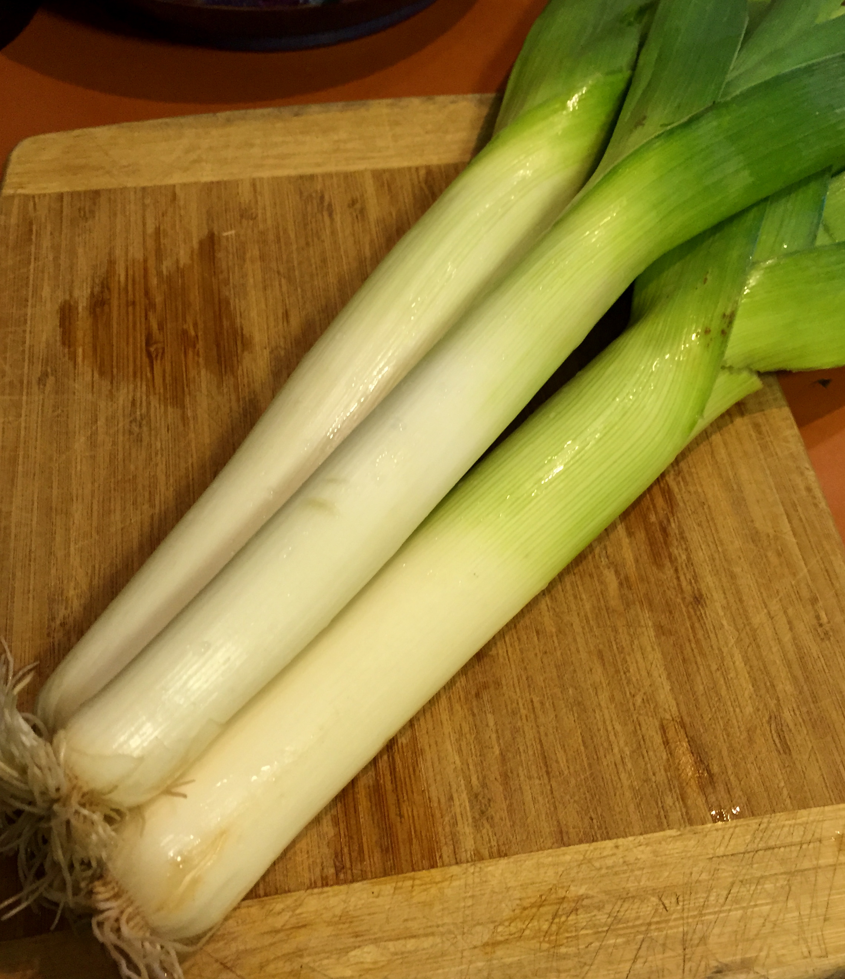
2-3 leeks
6-8 cloves of garlic (I tend to go heavy on the garlic
as this is one of my great loves)
1 bunch kale
1 quart of Vegetable Stock
1 can of Cannellini or Great Northern White Beans
Butter (optional)
Olive Oil
Salt and Pepper

Start by thinly slicing the leeks, the food processor does as great job at this! Put about a tablespoon of olive oil in a large soup pot and sauté over medium low heat. Next, dice the garlic and add to the leeks, taking care not to burn the garlic by cooking too long or on too high heat. Chop your kale into bite-sized pieces (I don’t bother destemming as the stems become soft with cooking.) Pour your stock into the pan and add the kale. Turn the stove up to medium high heat and allow the stock to just come to a boil. Immediately return the heat to the medium low setting and allow the soup to simmer for about 15 minutes. Next, add your beans, including the liquid in the can, this adds delightful depth to the soup. Add a pat of butter to the soup if you wish to create further richness, and season with salt and pepper to taste. Simmer the soup to gently for another 15 minutes so the flavors can meld together. This soup tastes great and keeps well. Enjoy!

